Lab 4
Areesha Raheel
55039
Problem solving

Lab Tasks:
1. Write a C++ program to:
- Input graph using adjacency list
- Apply greedy coloring
- Print assigned colors
Code:
#include <iostream>
#include <vector>
using namespace std;

class Graph {
int V;
vector<vector<int>> adj;

public:
Graph(int V) {
this->V = V;
adj.resize(V);
}

// Add edge
void addEdge(int u, int v) {
adj[u].push_back(v);
adj[v].push_back(u);
}

// Greedy Coloring
void greedyColoring() {
vector<int> result(V, -1);

// First vertex gets first color
result[0] = 0;

vector<bool> available(V, false);

// Assign colors to remaining vertices
for (int u = 1; u < V; u++) {

fill(available.begin(), available.end(), false);

// Mark colors used by adjacent vertices
for (int i : adj[u]) {
if (result[i] != -1)
available[result[i]] = true;
}

// Find first available color
int color;
for (color = 0; color < V; color++) {
if (!available[color])
break;
}

result[u] = color;
}

// Print result
cout << "Vertex : Color\n";
for (int i = 0; i < V; i++) {
cout << i << " : " << result[i] << endl;
}
}
};

int main() {
int V = 5;
Graph g(V);

// Example edges
g.addEdge(0, 1);
g.addEdge(0, 2);
g.addEdge(1, 2);
g.addEdge(1, 3);
g.addEdge(2, 3);
g.addEdge(3, 4);

g.greedyColoring();

return 0;
}
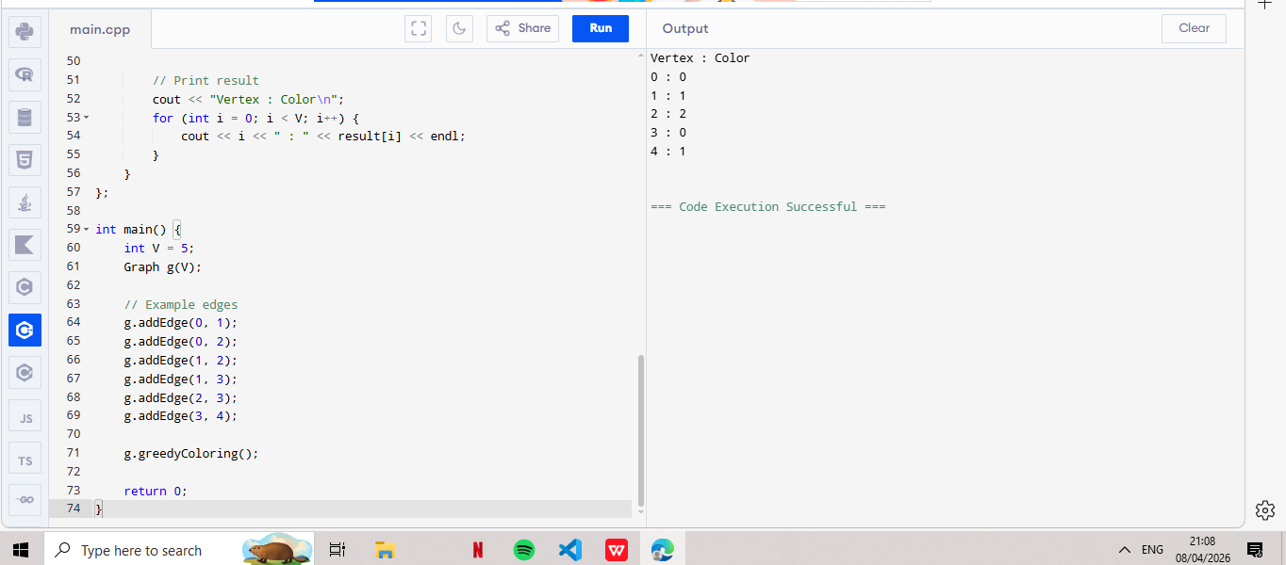
2. Write a program to:
- Count total colors used
- Output chromatic number
Code:
#include <iostream>
#include <vector>
using namespace std;

class Graph {
int V;
vector<vector<int>> adj;

public:
Graph(int V) {
this->V = V;
adj.resize(V);
}

void addEdge(int u, int v) {
adj[u].push_back(v);
adj[v].push_back(u);
}

void greedyColoring() {
vector<int> result(V, -1);

result[0] = 0;

vector<bool> available(V, false);

for (int u = 1; u < V; u++) {

fill(available.begin(), available.end(), false);

for (int i : adj[u]) {
if (result[i] != -1)
available[result[i]] = true;
}

int color;
for (color = 0; color < V; color++) {
if (!available[color])
break;
}

result[u] = color;
}

// Print colors
cout << "Vertex : Color\n";
for (int i = 0; i < V; i++) {
cout << i << " : " << result[i] << endl;
}

// ✅ COUNT COLORS (FIXED PART)
int maxColor = 0;
for (int i = 0; i < V; i++) {
if (result[i] > maxColor)
maxColor = result[i];
}

cout << "Total colors used: " << maxColor + 1 << endl;
cout << "Chromatic Number (approx): " << maxColor + 1 << endl;
}
};

int main() {
int V = 5;
Graph g(V);

g.addEdge(0, 1);
g.addEdge(0, 2);
g.addEdge(1, 2);
g.addEdge(1, 3);
g.addEdge(2, 3);
g.addEdge(3, 4);

g.greedyColoring();

return 0;
}
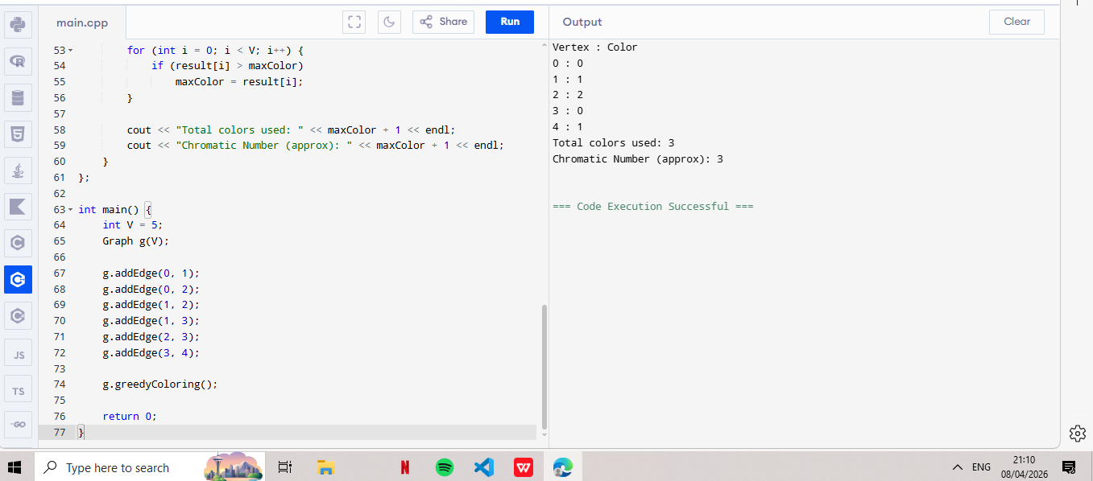
- Take any graph and check if it can be colored using only 2 colors or not?
Code: BFS Method
#include <iostream>
#include <vector>
#include <queue>
using namespace std;

bool isBipartite(vector<vector<int>>& adj, int V) {
vector<int> color(V, -1);

for (int start = 0; start < V; start++) {
if (color[start] == -1) {
queue<int> q;
q.push(start);
color[start] = 0;

while (!q.empty()) {
int u = q.front();
q.pop();

for (int v : adj[u]) {
if (color[v] == -1) {
color[v] = 1 - color[u];
q.push(v);
}
else if (color[v] == color[u]) {
return false; // Not bipartite
}
}
}
}
}
return true;
}

int main() {
int V = 5;
vector<vector<int>> adj(V);

// Same graph
adj[0] = {1,2};
adj[1] = {0,2,3};
adj[2] = {0,1,3};
adj[3] = {1,2,4};
adj[4] = {3};

if (isBipartite(adj, V))
cout << "Graph CAN be colored with 2 colors\n";
else
cout << "Graph CANNOT be colored with 2 colors\n";

return 0;
}
